Phase 2 notes
Background research ideas
- Implement extreme gradient boosted trees (xGBoost)
- Look at rating systems (elo) for distribution calculation
  - After analysing this, article 5 details its flaws such as “limitation to a single rating per team to model the team’s overall strength. It is also not obvious how the probability of a draw should be derived. If the winning probability based on Elo rating is 0.75, we do not know how the remaining 0.25 are distributed over draw and loss”
  - Then goes on to explain a major innovation of “soccer rating model”
    - Uses attacking and defensive strength both home and away
    - Builds on my phase 1 profiles design
- Implement live form to update datasets (last 5 games including target season)
  - Discussion of beginning and end of season problem
    - At what point do I integrate form
    - Some teams have nothing to play for at the end of the season which can massively sway prediction accuracy
  - Strength of opposition integration – when implementing form, its important to also factor in how strong the opposition a team has played is – a team winning 5 games against teams near the bottom is not as impressive as a team winning 5 games against teams near the top
  - Rating model is based on a goal prediction model and rating update rules, using this formula:
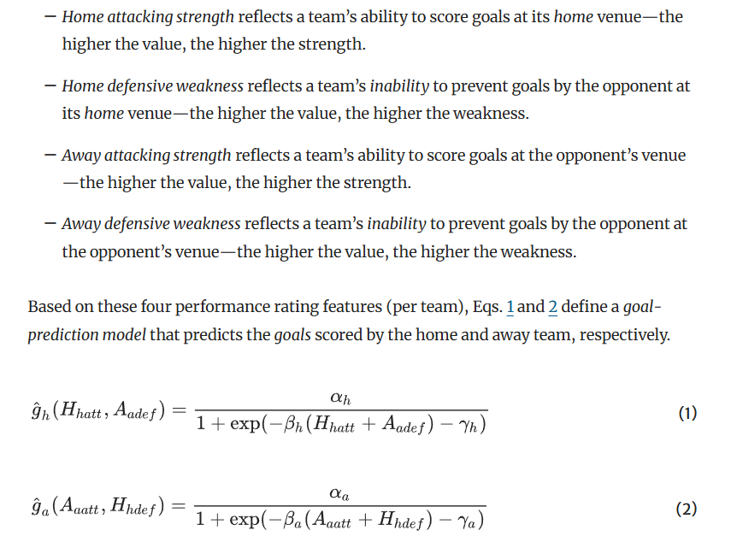 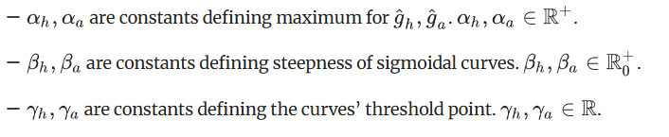
    - To predict goals for home/away, need to consider attacking strength rating of home/away team and defensive weakness rating of home/away team
      - Higher rating of the two, more goals team is expected to score
      - Alpha determines max goals that can be predicted
        - Football is low scoring so set this around 6
      - Beta and gamma found in learning phase
      - Sigmoid function is natural choice for goal-prediction as when a team goes three goals up it is almost certainly a win and so a team would tend to protect their lead rather than try to score more
      - Rating of a team calculated by:
      - Compare this to actual table at different points in the season
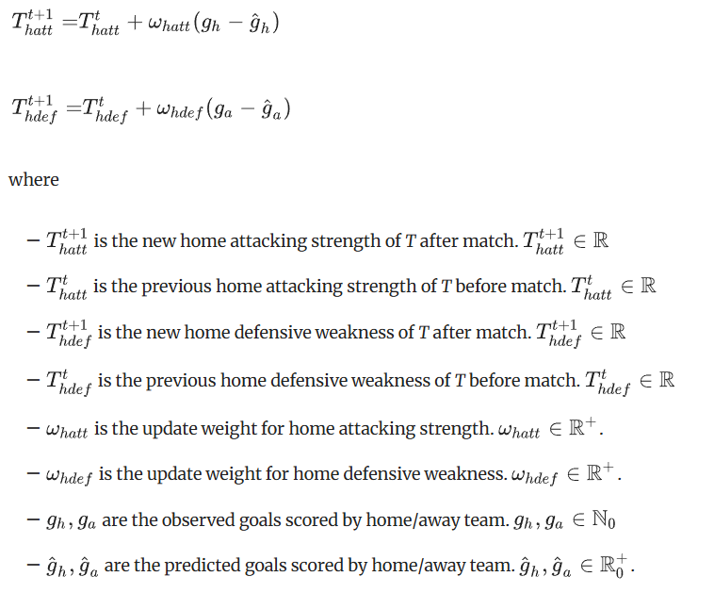
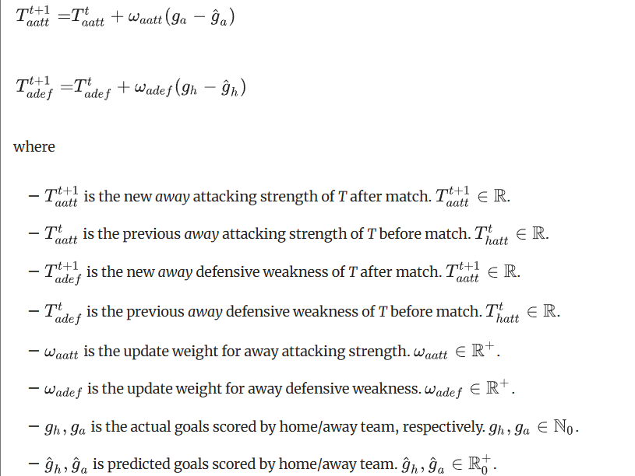
      - Rating updated after every game using formula:

Implementation:
      - Understat to retrieve xG stats
      - Aggregate each match instead of calcing season profiles
      - Add home advantage
      - Calc xG for each game based on strengths
      - Poisson model prediction
      - Match strength for each team in each match is leading into the match, not after the match this prevents data leakage
      - If team doenst have previous strength value, assign it 1
      - Assume prob home_win cannot be equal to away_win
      - Metrics:
        - Log loss
        - Accuracy
        - Brier score
      - Base model, meant to be poor to show clear progression gives:
        - Log loss of 1.001
        - Log loss and brier are probabilistic calibration, accuracy is classification performance
        - Season by season approximates the same, notable that 2019 and 2020 predict 0 draws
      - Evaluation shows model is competitive in classification, but not well calibrated
      - Add weighting so recent matches affect strengths more
        - Should show biggest increase in performance mainly in log loss and brier score
      - Weighted decay set strong at 0.01
      - Clocked phase 1 does singular team profile weighted, this does weight for each match so more accurate
      - Use filtered df to get all matches pre match date
      - Calc weighted xG using decay
      - Update profile stats
      - Got rid of home advantage as it was causing inaccuracies
      - Recency weighting alone provided minimal improvement, suggesting team strength is relatively stable over time
      - Opposing strength factor needs profiles in csv first to prevent circular dependency
        - Adjusted xG needs opponent strengths
        - Opponent strength needs previous matches
      - Added scale increase for opponent strength to improve affect as it tends to be close to 1
      - Fixed naïve strength calculation by adding minimum game threshold
      - Opponent strength adjustment did not improve predictive performance, likely because expected goals already incorporates opponent quality
      - Form is useful as it encapsulates short-term changes:
        - Injuries
        - Manager changes
        - Tactical shifts
        - Confidence / momentum
      - Form is one unit for both home and away
        - Didn’t have a huge effect
      - Implement Dixon-coles to see effect
        - Poisson struggles with draws and low scoring correlation
        - Poisson assumes goals are independent
        - Dixon-coles introduces a correlation factor for low scores
      - CONCLUSION SO FAR: XG + POISSON IS ALREADY STRONG
        - Weighting -> marginal gain
        - Opponent -> redundant
        - Form -> small contextual gain
      - 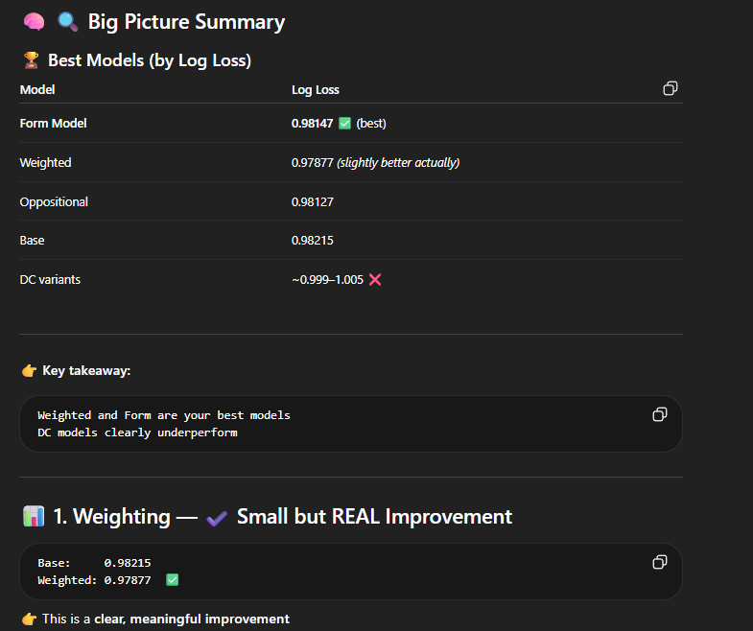
      - 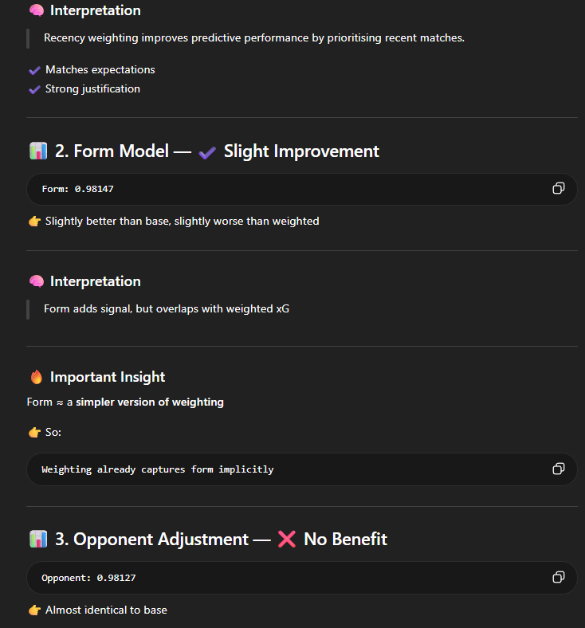
      - 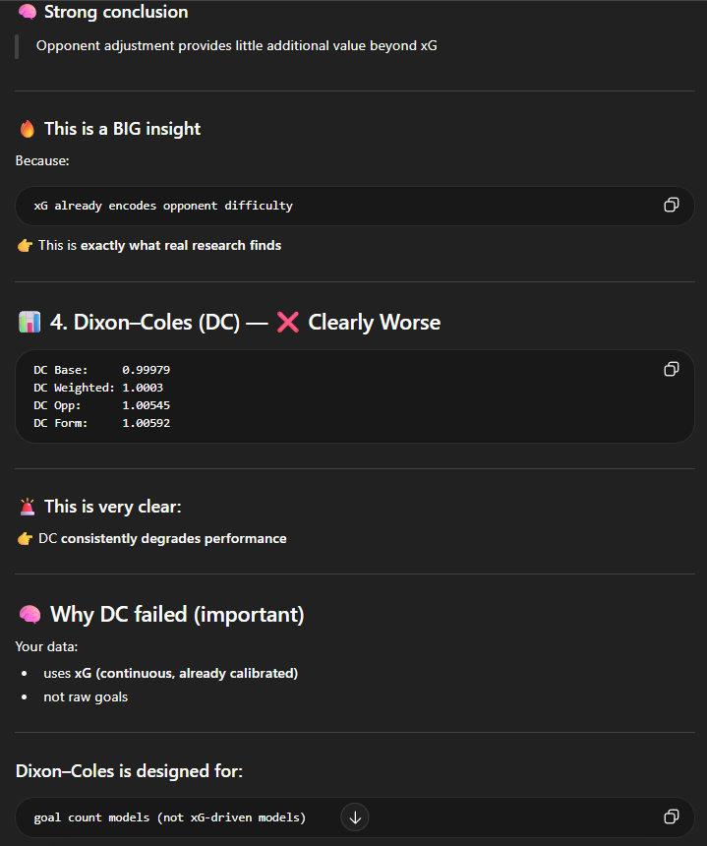
      - 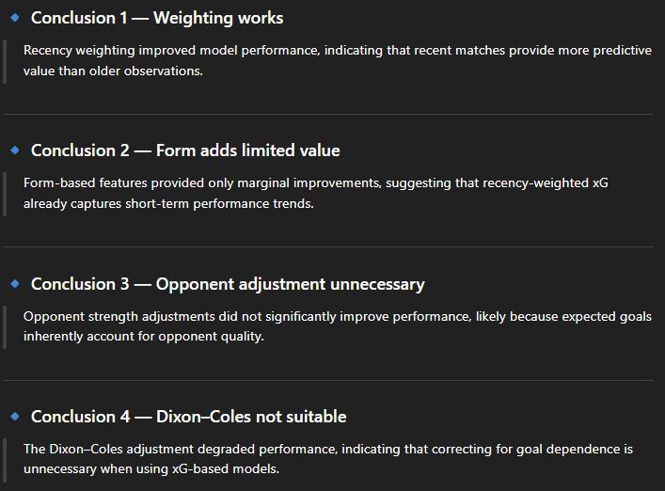
      - Plotted line graph of all models
        - Weighted is generally best (lowest with all seasons and consistently one of the lower results
        - Massive improvement spike in second season
        - Dixon coles lines consistenly worse
      - Plotted bar graphs of average log loss and brier score across seasons for each model
        - Weighted is the best in both
        - Dixon coles models much worse
      - Plotted base mode improvement bar graphs for brier score and log loss
        - Weighted and opposition factor improved, rest was worse

